The Industrial Revolution II

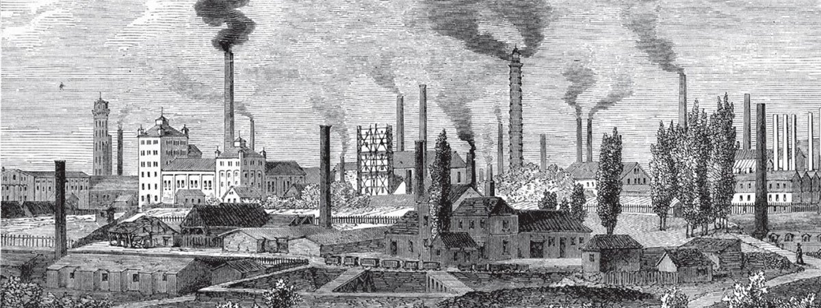
Group work:
Form groups of three students; 1 mavo, 1 havo, 1 vwo student. Every member of your group is going to try to find an answer to some questions. In order to do so, you are allowed to use the internet and browse the web. It is important that every member of the group knows the answers eventually, so it is your responsibility to answer your questions correctly and to report about them to your group members. When you share the answers in your group, don’t forget to take notes! The information you are receiving from your group members will be used as input for a later assignment. You can take notes, share information and/or photos on the next page.

- MAVO:
Go online any find out:
- What did the cities in England look like during the age of the Industrial Revolution? Paste a photo of a typical city in this document. Use your own words to describe the buildings (inside and outside), the streets, the people etc.
- How does the building style of the Industrial Revolution stay visible today? Find a modern photo of a building or buildings from the era and paste it in this document. Write down how these buildings are used now.

- HAVO:
- During the Industrial Revolution, many people lived in so-called ‘workhouses’. Find out who lived here and why. Also find out what the circumstances in these workhouses were like. Find information about what kind of work they had to do, how they came to live in the workhouses, what they dressed in, what they ate etc.

- VWO:
- Find out what a day in the life of a factory worker in England looked like during the Industrial Revolution. What did they eat? How long did they work during a day? How were they treated at work? How big were their families at the time? What kind of work did they have to do?
- Who worked in the factories? Men or women? Adults or children?

___________________________________________________________________________
Answers:
Part A. | Answers given by:
Part B. | Answers given by:
Part C. | Answers given by:

